TERM 3

GRADE 10 – PROJECT

Python
Name: |  | Date:
SIS No |  | Grade
Group: | N/A (Not Applicable) | Start Time:
Signed |  | Finishing Time:

Picture 1
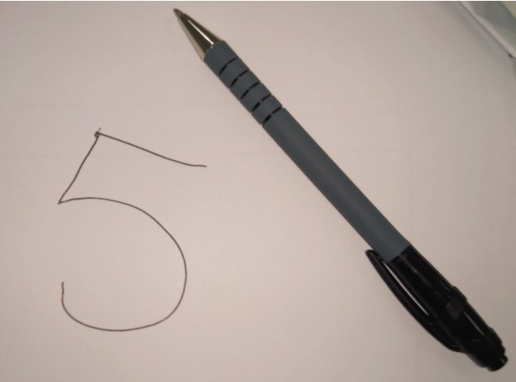

Picture 2
PROJECT OBJECTIVE
You will be applying your knowledge from the Artificial Intelligence Project, covering the following student learning outcomes (SLO’s):
- apply programming concepts learned to solve real-world problems.
- explain the basic principles of artificial intelligence and machine learning.
- develop code to classify images of handwritten digits using artificial intelligence and machine learning.
- analyse the performance of machine-learning algorithms.

EQUIPMENT REQUIREMENTS
Laptop or Computer, Camera, Paper, Black Marker, Python 3.X, PyCharm / Notepad / Notepad++.

PROJECT INTRODUCTION
To complete the project, you need to perform each of the following:

1. You will answer several questions on ‘artificial intelligence’ and how it could help the UAE. You will then visually demonstrate how to teach a computer to find out if an image is an orange or a banana using training and testing code.

2. An image is stored as a list of lists. Using the letter ‘A’ example, you will show how the letter ‘H’, could be represented digitally, and how it can then be represented in a single list in Python.

3. The SKLEARN dataset module in Python contains images of digits. You will answer questions about this dataset, and how we can use Python list functions with the dataset.

4. The SKLEARN dataset module contains a number functions that you will import. You will briefly describe what each function does.

5. To test the machine we use known classified samples. You will answer questions from the code, and describe classification and confusion matrix reports.

6. To test our own images of digits, we need to use some functions of the SCIKIT-IMAGE module beforehand. You will answer questions from the SCIKIT-IMAGE code.

7. You will test the code using 20 of your own handwritten images of digits. You will generate the code to classify all 20 images. You will develop the code to generate your own classification report and confusion matrix for your results. You will answer some questions from your confusion matrix results.
Finally, you will explain and give an advantage or disadvantage of Artificial Intelligence.

QUESTION GUIDELINES
- Please fill in the areas highlighted.
- Type and execute your code using PyCharm software (or any other Python editor).
- Show your code and output to your teacher.

In the case where you are not able to show your code and output to your teacher:
- save your program.
- take a print screen of your code and an output of your code.
- save your print screen file.
- submit the saved file as a hardcopy or softcopy to your teacher.

PROJECT – WORK PLAN
# | Work Steps | Step Completion & Values | Rem  arks
1 | A. Write what ‘artificial intelligence’ and ‘machine learning’ are.  B. Visit www.uaeai.ae on your web browser, and view the main video and read the main page.  Give your own suggestion for how Artificial Intelligence could be used for the UAE.  C. Using artificial intelligence and machine learning, fill in the diagrams below to visually demonstrate how to teach a computer to find out if an image is an orange or a banana.  Drag and drop the answers from the ‘Answer Key’ | A. Artificial Intelligence is _________________________________________________________________________ __________________________________________________________________________  Machine learning is: _____________________________________________________________________________ __________________________________________________________________________  B. Suggestion: ________________________________________________________________________________________________ __________________________________________________________________________  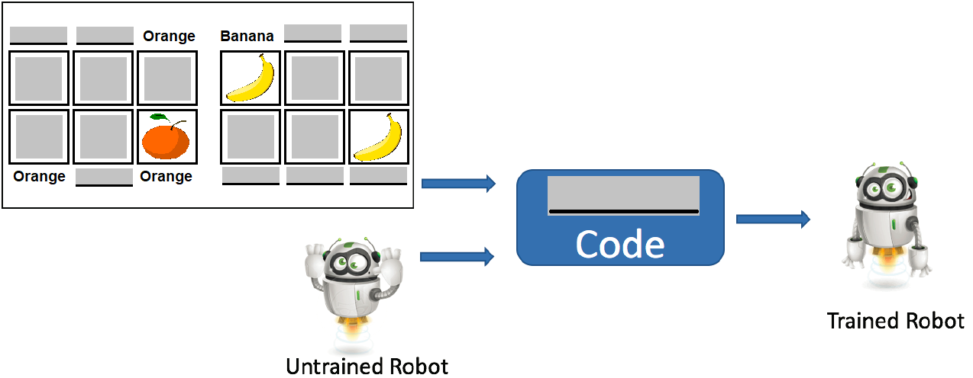  C.  Training  Stage:  _____________________________________________________________________________________________________________________________________________________________________________________  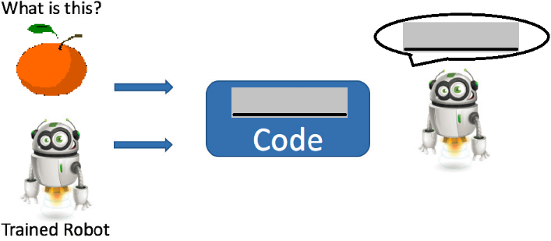  Testing  Stage:  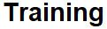  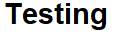  Part C  Answer Key:
2 | An image is stored as a list of lists.  A. Using the shown letter ‘A’ example, show how the letters ‘U’ and ‘E’, could be represented, for the UAE.  Please shade the boxes in black.  B. Show how your letters could be digitally stored in a single final list called imageU and iageE | A. Show how the letters ‘U’ and ‘E’ can be represented  (Hint, for each try on a blank piece of paper first, on an 8 x 8 grid )  Letter U:  listU1 = [ , , , , , , , ]  listU2 = [ , , , , , , , ]  = [ , , , , , , , ]  = [ , , , , , , , ]  = [ , , , , , , , ]  = [ , , , , , , , ]  = [ , , , , , , , ]  listU8 = [ , , , , , , , ]  imageU = [ , , , ,  , , , ]  Letter A:  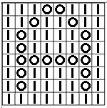  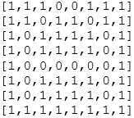  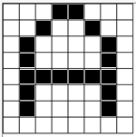  Letter E:  listE1 = [ , , , , , , , ]  listE2 = [ , , , , , , , ]  = [ , , , , , , , ]  = [ , , , , , , , ]  = [ , , , , , , , ]  = [ , , , , , , , ]  = [ , , , , , , , ]  listE8 = [ , , , , , , , ]  imageE = [ , , , ,  , , , ]

# | Work Steps | Step Completion & Values | Rem  arks
3 | The SKLEARN dataset module contains images of digits.  A. For a machine to learn, which of the following number of images in its dataset would provide a more correct answer? Why?  a) 10 images  b) 100 images  c) 1000 images  B. Fill in the function name that returns the length of the list ’images’. What is the list length when running the code?  C. Write the code to put the first 1000 elements of the list ‘images’ into a sublist.  D. To prepare the data for machine learning we will use the first 1000 elements in the SKLEARN dataset module for training. What will we use the remaining elements in the SKLEARN dataset module for? | A. Answer:  _______ images would provide a more correct answer.  Reason : __________________________________________________________________________________________________________________________________________  B. Fill in the function name that returns the length of the list ’images’.  from sklearn.datasets import load_digits  digits = load_digits()  images = digits.images  print("Total number of images:", (images))  What is the list length returned when running this code?  Answer: Total number of images: _____  C. Answer:  imagesSublist =  D. Answer:  __________________________________________________________________________________________________________________________________________
4 | The SKLEARN dataset module contains a number functions that you will import.  A. Briefly describe what the following functions do:  - load_digits,  - SVC,  - classification_report  - confusion_matrix  B. 'training_samples', 'training_targets', 'testing_samples' and 'testing_targets' are all types of? | Code Extract:  from sklearn.datasets import load_digits  from sklearn.svm import SVC  from sklearn.metrics import classification_report,  confusion_matrix  digits = load_digits()  images = digits.images  target = digits.target  data = images.reshape((1797, 64))  classifier = SVC(gamma=0.001)  training_samples = data[0:1000]  training_targets = target[0:1000]  testing_samples = data[1000:1797]  testing_targets = target[1000:1797]  A. The load_digits function:  _____________________________________________________________________________________________________________________________________________________________________  The SVC function:  _____________________________________________________________________________________________________________________________________________________________________  The classification_report and confusion_matrix functions: _____________________________________________________________________________________________________________________________________________________________________  B. Answer:  ____________________
5 | To test the machine we use known classified samples. Answer the following questions from the code:  A. What does classifier.fit() do when we pass run this function with the training_samples and training_targets lists?  B. What does classifier.predict() do when we pass run this function with the testing_samples list?  C. Look at the following classification report, displayed from running the code.  Which did the computer classify easier, digit '3' or digit '6'?  D. Look at the following confusion matrix report displayed. The fifth row highlighted in the matrix gives the confusion result for digit 4.  What can the information in this row tell us? | Code Extract:  classifier.fit(training_samples, training_targets)  predicted = classifier.predict(testing_samples)  print("Classification report for classifier")  print(classification_report(testing_targets,  predicted))  print("Confusion matrix")  print(confusion_matrix(testing_targets, predicted))  A. Answer:  _____________________________________________________________________________________________________________________________________________________________________  B. Answer:  _____________________________________________________________________________________________________________________________________________________________________  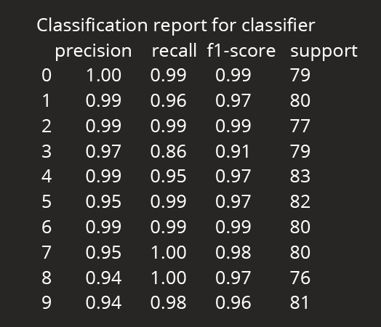  C. Classification report:  Answer: Digit _____.  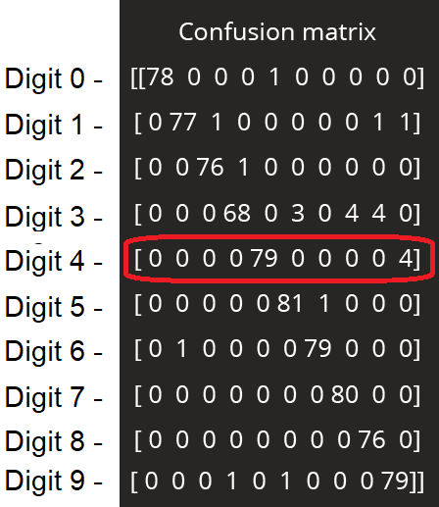  D. Confusion matrix report:  Answer:  _________________________________________________________________________________________________________________________________________________________
6 | To test our own images of digits, we need to use some functions of the SCIKIT-IMAGE module beforehand.  Answer the following questions from the code:  A. What does imread() do when we pass run this function with the 'testImage.png' image file, and the word 'True'?  B. The functions resize() and reshape() are performed to resize and reshape the images. Why do we need to do this?  C. Fill in the blanks in this sentence. | Code Extract:  from skimage.transform import resize  from skimage import io  ...  img = io.imread(testImage.png, True)  img = resize(img, (8,8), mode='reflect')  img = (1-img) * 16  vector = img.reshape((1,64))  print(classifier.predict(vector))  A. Answer:  _________________________________________________________________________________________________________________________________________________________  B. Answer:  _________________________________________________________________________________________________________________________________________________________  C. 'vector' is a long _________ of pixels. The function classifier.predict() will then predict the ___________ of the image.
7 | Test the code using your own images of digits.  A. Handwrite the digits 0 to 4 four times, and save as seperate images.  B. To read all 20 images, we need to ensure that the code looks at them.  C. In the code, generate the classification report and confusion matrix for all your images.  PLEASE SPEAK TO YOUR TEACHER FOR GUIDANCE.  D. Run the code for all your digit images. Fill in your own confusion matrix for the 20 images of digits.  E. Which of your digits did the computer find easiest and hardest to classify correctly?  F. Take a screenshot of your completed code, and the generated output.  G. Explain and give an advantage or disadvantage of Artificial Intelligence. | A. On a separate page, using a black marker write digits 0 to 4 like below, four times. This will make a total of 20 images of digits. (* Hint, use different handwriting, or handwriting from a different student)  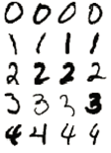  Take a picture of the above filled in table of digits and use the SnippingTool in Windows,to ‘crop’ your images into 20 individual images of each digit.  Name each of the 20 images appropriately, for example for the fourth image of your digit 3 could be “image3-4.png”.  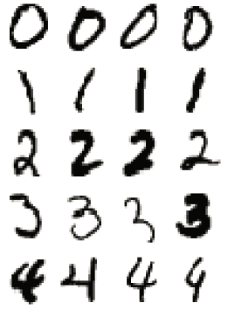  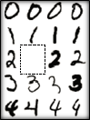  Snipping Tool used to crop each image, for example:  image2-2.png  Single digital photo of all digits.  Handwritten on paper  Save all 20 image separate files into a folder.  B. Drag all 20 image files into your Python project. Show your teacher an image of at least one of your own handwritten digits in your Python project.  The code extract below classifies two of the digits (0 & 1):  #images to classify  allimages0=[ "image0-1.png ", "image0-2.png ",  "image0-3.png ", "image0-4.png "]  allimages1=[ "image1-1.png ", "image1-2.png ",  "image1-3.png ", "image1-4.png "]  for thisimage in allimages0 + allimages1:  ...  Develop the code to test the machine on all the images you saved. Write the code needed to classify all 20 of your own images of digits:  C. Write here the code that generates the classification report and confusion matrix for your own images of digits:  D. Fill in your own confusion matrix.  Confusion matrix  [[  ]]  E. Easiest digit: _______ Hardest Digit: _______  F. Generated output Screenshot:  G. Answer:  ____________________________________________________________________________________________________________________________________________________________________________________________________________

